Kia ora koutou!
Here’s some content you can copy & paste into your next school newsletter. Images and text are found on our Movin’March google drive, under “Movin’March 2026 images”

Don’t forget to edit the yellow highlights below with info that’s particular to your school.
When | Suggested text for your newsletters: | Suggested images with links to download:
Before Movin’March  23rd Feb 2026 | Let’s Get Movin’ in March!  We’re a Movin’March school and counting down to Monday 2nd March when we’ll be encouraging ākonga (students) to walk or wheel to kura (school).  Walking or wheeling to school is a great way to get active, know your neighbourhood, get energised to learn, AND take care of the environment.  This year, we’re taking part in the new WoW Class Challenge. Each student will set their own goal for March and record this on a bookmark they can take home. We’ll record trips in class on a wallchart, and those who are working towards their goal may win small prizes.  And we can enter in the regional competition for some great class prizes!  Info for whānau:  www.movinmarch.com |   “Our school is…”  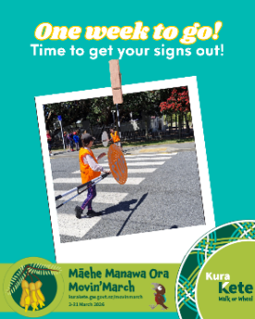  “One week to go”
Week 1  2nd March | Movin’March is here!  We’re proud to be a Movin’March school and this month we’re looking forward to seeing whānau and students walking or wheeling to or from school.  Walking, biking, and scooting is a great way to improve well-being – and it’s also great for the planet!  For those who live too far away to walk or wheel, you can try out Park and Stride – park a block away and walk from there. And buses count too!  Remember to work towards your WoW Class Challenge goal and keep an eye out for the spot prizes! | 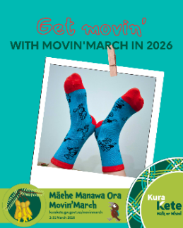  “Get Movin’”  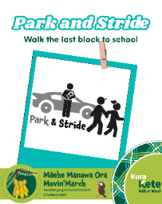  “Park and Stride”    “Bus train or ferry”
Week 2  9th March | Movin’March – Week 2!  We’re loving all the trips being entered in Te Haerenga o ngā Tamariki for the WoW Class Challenge!  Remember if you walk or wheel, we’ll tick off your trip on the class wallchart – and there may be spot prizes or stickers up for grabs!  Classes who enter 5 days of trip data on Te Haerenga o ngā Tamariki can be in to win awesome prize packs – there are prizes from Micro Scooters and MyRide, with Pedal Ready, and class trips to Staglands, Zealandia and Wētā Workshop up for grabs! |   “aiming for better”  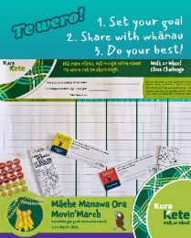  “Te wero the challenge”
Week 3  16th March | What motivates you to WoW?  We’re a Movin’March school and every day we’re adding trips to our class wallchart as part of the WoW Class Challenge! All of our ākonga (students) have set a goal for themselves – something they think they can achieve – even if it’s walking one more day a week or getting dropped off a block away.  We know our ākonga are motivated by different things; whether it’s health, connection, adventure or te taiao (environment). What about our whānau? Are you up for the challenge? |   “Walk or wheel”  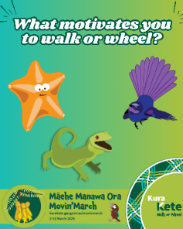  “What motivates you”
Week 4 | We’re celebrating!  This year Movin’March is turning 17 and there are a record number of tamariki taking part, including yours. With just over a week left this March we’re keen to get help your kids achieve their goals.  To celebrate we’re holding a Walk or Wheel Whānau Day on *** [insert WoW day info if relevant] |   “One week left”
Week 5 | Movin’March – Final week!  We’re very proud of all our tamariki for giving their best effort to walk or wheel a bit more this March. Everyone worked hard and this shows in class. As the term wraps up, please keep encouraging your tamariki – especially on those colder days. It really helps them arrive on time, refreshed and without the stress of morning school runs!  Our classes have entered the WoW Class Challenge, and we’re excited to share the results for our schools:  [results here if you want].  All classes are in the draw to win some great prizes such as class trips and Wheels days with Pedal Ready.  Thanks again to all our whānau for your support! | 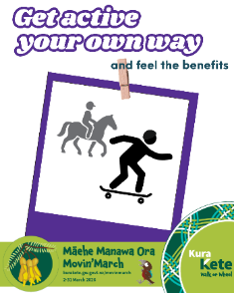  “Get active…”    “Our school is…”

General info you can share at any time:

Park & Stride
If you live ‘too far away’ why not try a Park and Stride? You can still get your passport stamped at the gate! It helps reduce congestion around the school gate, gives tamariki exercise and whānau get to share precious moments on the way to or from school.
(**Schools can add suggestions of places to park nearby where students could safely walk the rest of the way to school)
More info for schools: https://kurakete.gw.govt.nz/themes/community/park-and-stride/

Or

If your family lives too far away, why not park a short distance away from the school gate and walk or wheel the rest of the way? For more information see our Park & Stride tips or try parking at ** (school inserts safe place to park where families could walk/wheel from to get to school)

Walk or Wheel Day
We will be holding a special day on ** where we encourage all tamariki to **. We really encourage whānau to walk or wheel - even for just one day and join in the Movin’March fun!

Tips for your WoW day: https://kurakete.gw.govt.nz/movinmarch-2026/wow-family-day/

Ideas for all the Whānau:
- Check our Walk and Wheel Safety page for guidelines for whānau to safely walk or wheel to school
- Have a chuckle while you learn all about scooter safety with our scooter safety videos featuring the cast of TV show Wellington Paranormal
- Micro Scooters are not only awesome sponsors for Movin’March, they also have awesome safety tips or check out Waka Kotahi’s comprehensive Education Portal
- Get more information about Walking School Buses on our Movin’March website.

